Name: Ammar Khan
Roll No: 2017-BSCS-146
Subject: Oop(Th)

Q1. What is GIT?
Ans: GIT is basically a Version Control System. It is used to detect changes in any file which is being used by multiple people. And it can be access at anywhere and at anytime by any person of the group.

Q2. What is the difference between GIT & SVN?
Ans: SVN is a Centralized Revision Control System, and GIT is a Distributed Revision Control System. In SVN the remote commits are slow. In group, if two developers write the right code and the third one does some mistake due to the third one the whole repository crashes whereas, in GIT only the right code is send to the central repository. And if someone does the mistake it does not effect on the central repository.

Q3. Write a command to commit your work in GIT?
Ans: git commit –m ”first command”.

Q4. Create a repository with your unique roll no. in Github?
Ans:
1. Sign in into your github account.
2. Click on start project.
3. Then I will write my repository name as “ammar146”.
4. Now I will select whether its private or public.
5. And then I will click on Create Repository.

Q5. What are the advantages of using GIT?
Ans: The biggest advantage of using GIT is branching. I can involve as many users in my project. I can see the change if any developer will make. I can use it at anytime whether in office or home. And the biggest advantage is that I can merge as many branches into a central repository as I want.

Q6. What is GIT clone?
Ans: Git clone is a command which is used to target the particular repository and to copy that targeted repository.

Q7. What is the command to delete the branch?
Ans: git branch –d

Q8. Explain the architecture of GIT in your own words?
Ans:
1. Check the git status.
2. Get the patchset.
3. Checkout a local branch.
4. Pull the recent contents from master.

Q9. How to resolve conflicts in GIT?
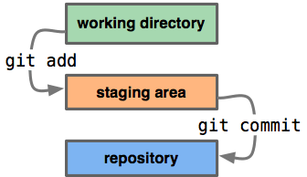
Ans:

Q10. Name the different vendors that are working on VCS.
Ans:
1. Visual Studio: Team Foundation Server
2. Git
3. Helix VCS
4. Sub Version
5. Mercurial

